LAB 03: Junit Intro
- Clone your github repository, open it as a workspace.
- Open the starter code:
  - Download the starter code of Lab 03 (file lab03.rar) from the course website.

  - Unzip the file into your eclipse workspace (cloned repository).

  - Open eclipse and import your project using “import an existing Maven project”.

  - Read the provided Stack class to get familiar with it, our objective is to write unit tests for it.

- We will create test cases for the class Stack:

  - Add a Test Class to your project: In the folder src/test/java, create a new class StackTest (in package with exactly the same name as the class to test).

  - Import the Junit classes/functions:
import static org.junit.jupiter.api.Assertions.*;
import org.junit.jupiter.api.Test;

(Note: In Java, the import static statement is used to import static members (fields and methods) of a class so that you can access them without qualifying them with the class name -> useful for assertEquals for example.)

  - Create a test case to test if a sequence of push->push->pop pops correctly the latest pushed element.

push(“Z”)->push(“A”)
assertequals(“A”, pop()) : The popped element has to be equal to A otherwise there is a problem in our Stack.

  - Right-click on pom.xml and execute run as->Maven test. You should get a report that all test passed.

  - Modify the previous test to force it to fail (assertequals(“Z”, pop()).

  - Add other test cases:

    - Test that popping an empty stack should raise an exception:
@Test
public void pop_empty_stack() {
NoSuchElementException thrown =
assertThrows(NoSuchElementException.class,
() -> stringStack.pop(),
"Expected pop from empty Stack to throw, but it didn't"
);

assertTrue(thrown.getMessage().equals("Stack is empty,can’t pop"));

}
    - Test that pushed elements are popped in reverse order.

- Install github copilot plugin in eclipse:
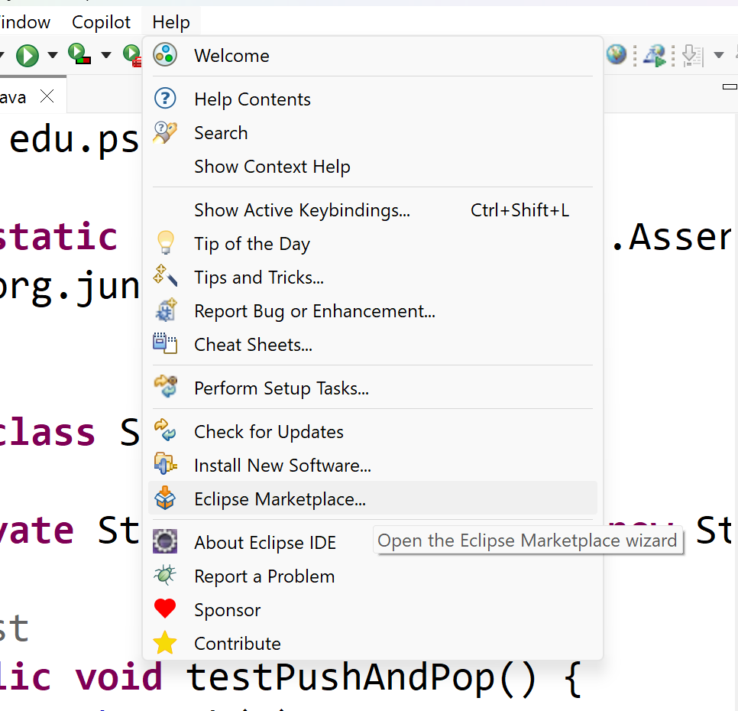

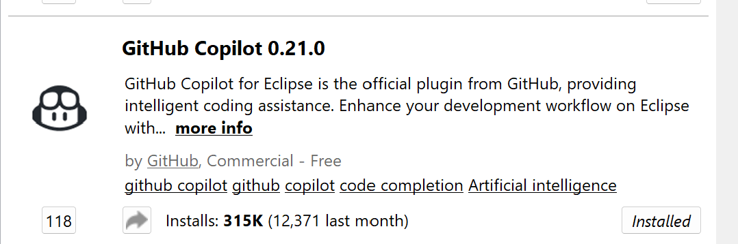

- Use your AI copilot in “agent mode” to generate more test cases for the Stack class. Ask the model to cover edge cases:

Write JUnit 5 tests for the Stack class. Requirements:
- Test each public method's normal/expected behavior first.
- Cover boundary and edge cases (null inputs, empty collections/strings, zero/negative/max values, off-by-one boundaries).
- Cover error conditions: invalid input, exceptions thrown, and their exact type/message where relevant.
- Test any branching logic (if/else, switch) so every distinct path is exercised.
- If the class has state, test that state changes correctly across multiple calls (not just one call in isolation).
- Don't test private methods directly, test them through the public API.
- Don't write redundant tests that assert the same thing with trivial variations, favor fewer, well-chosen cases over exhaustive combinatorics.
- Before finishing, list which methods/branches are NOT covered and why (e.g., trivial getter, unreachable code) so I can sanity-check completeness.

- Review the generated code and correct it if necessary.

Submission: Finally commit and push your changes to your github repository

